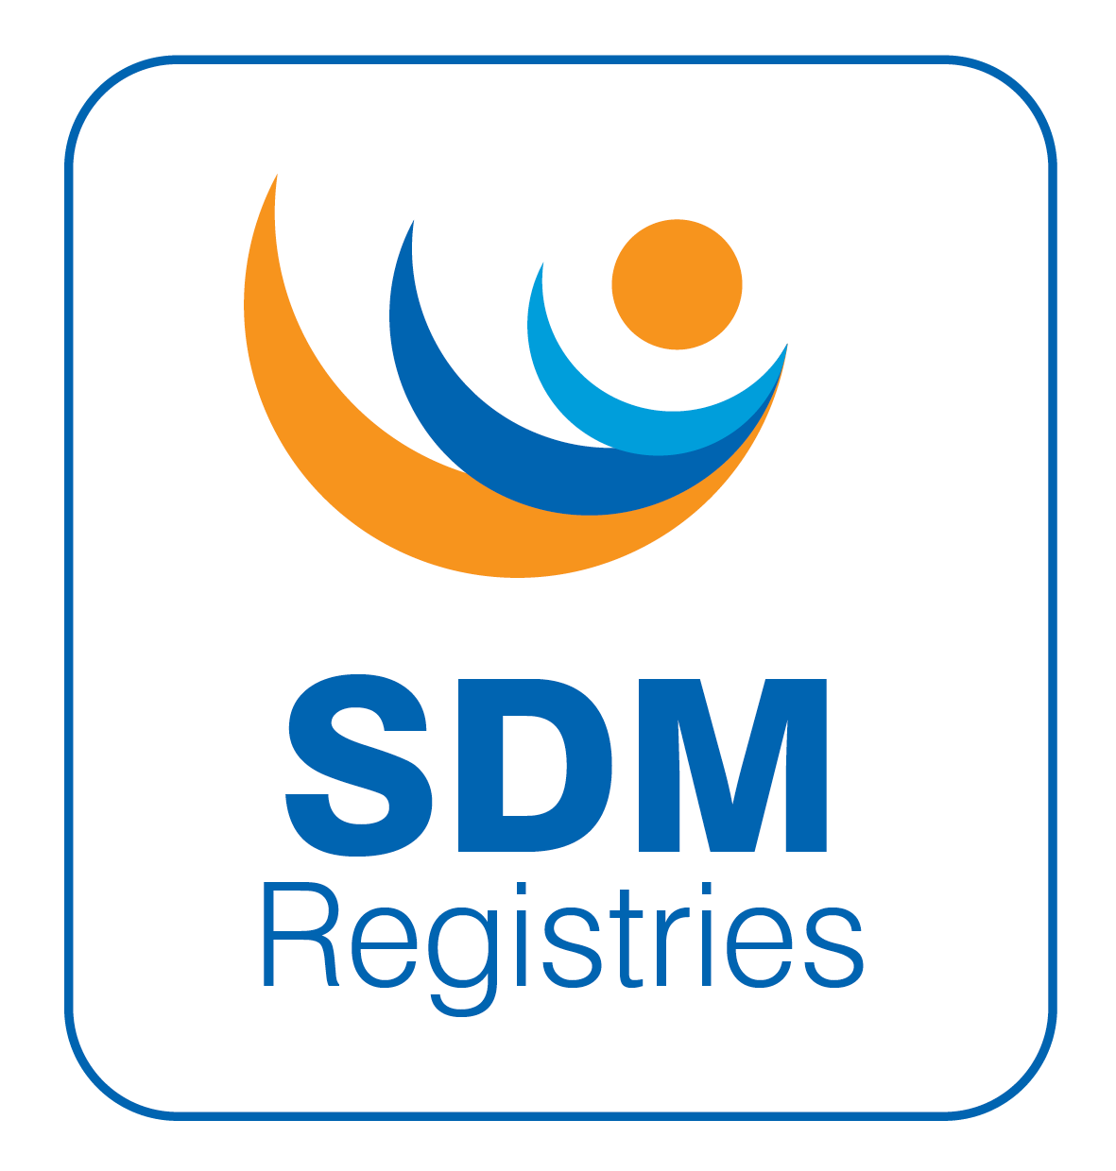
SDMregistries

Data Request Form
1 Mandatory questions are marked with a star (*)

Read the document Conditions of approval of the SDMregistries

Read the PProcedure for obtaining data from the Registry for research

Read the DData Access Policy
Read the Data Access & Support Fees
Read the Data Exchange Policy

Read the PPublication Plan

Consulted the Data Dictionary to identify variables required

Consulted the list of Active and Completed studies

Read the PProcess for using & reusing data from the registry Read the PPrivacy Notices
- Please confirm that you have read all of the documents above before completing this form.*
- Yes
- No

Tips for completing this application form.
The form has Save and Continue later option. Please SAVE regularly if completing in one go.
It is recommended that you browse through the questions and prepare some sections of the application offline and then copy and paste into the web form.
An ooffline version of this form is available for preparing a draft of the application.

For help with this form please e-mail: info@sdmregistries.org
V10
Created: 01/01/22
Revised: 3/2/26
Review: 3/2/27

- The project must be discussed in detail with the Project Management Group at
least one month prior to the deadline. Please complete these mandatory questions to continue:
Discussed with (names of Project Management Team members) *
On (date(s) of discussion) *

- I confirm the project has been discussed in detail with the Project Management Group at least one month before the submission date. *

- Yes
- No

- Details of Principal Investigator ‡ *

Name

Email
Name and Address of Institution/Sponsor

- Details of Coinvestigator(s) ‡ *
Name, institution name & e-mail address

- Full Name of Project *

- Short Name of Project for Communication Purposes ‡ *

- This application has been discussed with all the coinvestigators *
Notification of approval of this application will be sent to all coinvestigators

- Yes
- No

- This application is: *

 a new application (Move to Q11)
 a revision of a previously submitted application  an extension to a previously approved project

- Details of previous application/study (NA for a new application)
Study ID or Date of submission to DAC, Short title & PI

- Has this project been peer reviewed and approved by any organisation? *
(e.g. funding body, ethics body, regulatory agency, other formal organization)

- Yes
- No (Move to Q13)

- Please provide details of these organisation(s) and the date and duration of approval *

- If not approved, is there a date for submission

- Yes
- No (Move to Q15)

- Date for submission
dd.mm.yyyy

- Plain language abstract of the project ‡ (max 100 words) *

- How will this project improve the health of the people with the condition that is being studied? *

- Background and rationale for support required (max 500 words) *

- What is the primary hypothesis of the project? *

- What is the primary outcome that will be measured? *

- Please select one of the following fields for the primary outcome:

 Anthropometry
 Basic Mechanisms  Biochemistry
 Bone Cancer
 Cardiovascular
 Communication and Understanding  Epidemiology
 Fertility
 Gender Development  Genetics
 Hormone Replacement  Metabolic
 Neurocognitive Development
 Quality of Life  Sexual Function
 Other (Please specify:)

- What are the secondary outcomes that will be measured?

- Please select all of the following fields for the secondary outcomes:

Anthropometry

Basic Mechanisms

Biochemistry

Bone

Cancer

Cardiovascular

Communication and Understanding Epidemiology
Fertility

Gender Development Genetics
Hormone Replacement Metabolic
Neurocognitive Development
Quality of Life Sexual Function
Other (Please specify:)

- Describe the methodology including project design (max 500 words) *

- State the inclusion criteria of the cases that will be recruited *

- State the exclusion criteria of the cases that will be recruited *

- Is the project considered to be a Health Care Quality Improvement Project *
(ie the focus of the project is on the quality of health care incl patient safety, patient experience or boosting clinical effectiveness; the design of the project should consider an audit cycle that includes collection of baseline data to understand the benchmark and then an intervention followed by a reassessment of the effect of the intervention on the benchmark)
- Yes
- No (Move to Q28)

- Please explain in less than 500 words why the project is considered to be a Health Care Quality Improvement Project. *

- Specify the data that are required from the Registry by completing and
uploading the Data Request Justification Form *
The SDMregistries team can provide assistance to complete the DRJF

- For deidentified data, please specify whether the data need to be linked to source data *
- Linkage to source data is required (pseudonymised data)
- No linkage to source data (anonymous data) (Move to Q31)

- Please justify why linkage to source data is required *

- Does the project require identification of individual centres or countries?: *

- Yes
- No (Move to Q33)

- Please justify why identification of individual centres or countries is required:
*

- What data analyses are planned? *

- Do you have any inclusion or exclusion criteria of the centres that will need to be approached? *
- Yes
- No (Move to Q37)
- Not sure (To discuss with PMG)

- Inclusion criteria if any (eg geographical scope)

- Exclusion criteria if any (eg geographical scope)

- In the case of missing data, will there be a need to contact participating centres? *
- Yes
- No

- Do the investigators intend to collect any data or biomaterial that are not collected as part of routine clinical practice? *
If intending to obtain any biomaterials (eg. samples), there may be a need for a separate centre-to-centre transfer agreement.
- Yes
- No (Move to Q42)

- Do the investigators have ethics/IRB approval for collecting this additional data or biomaterial? *
- Yes
- No (Move to Q41)

- Please provide details of ethics/IRB body and date and duration of approval *

- Is there a plan to apply for ethics/IRB approval? *

- Yes
- No

- Will the project require collection of patient reported outcomes (PROs)? *

- Yes
- No (Move to Q47)

- Will there be a need to collect this through the registry platform as: *
Online reporting
Uploaded copies
Other, specify:

- Are the PROs collected through the use of validated tools?

- Yes (Move to Q46)
- No

- Please provide further details of the PRO Tool
Non-validated tools that collect PROs have little scientific value and will require further discussion and may delay the launch of the project.

- Are there any licensing restrictions or costs for using the PRO?

- Yes
- No

- Full data tranches are provided in March and September. Will the investigators require a data tranche once or twice a year? *

- Will the investigators require raw data or cleaned data? *
(Please discuss with the Registry team prior to submitting application)

 Raw data (Move to Q50)
Cleaned data
- Please provide further details of requirements for cleaned data

- Has the project been funded? *

- Yes
- No (Move to Q54)

- Source of funding *

- Start date of funding *
(can be approximate)
dd.mm.yyyy
- End date of funding *
(can be approximate)
dd.mm.yyyy

- Is there a plan to apply for funding? *

- Yes, Specify (Move to Q56)
- No

- How will the data access or study support costs be covered? *

- Please explain whether you have protected time or local resources for performing the research that will be required once the data are supplied to you. *
(e.g. to clean the data and analyse the data, follow-up on queries, liaise with the Project Management Group and writing outputs)

- Have patients, parents, public been involved in the development of this project? *
- Yes
- No (Move to Q60)
- Please explain how patients/public have been involved in the development of this study. *

- Please upload supporting letter. *
Upload optional document (eg. a letter of support from a patient association)

- Please explain why there was no need for patient/ public engagement. *

- Would you be interested in writing a short piece in the SDMregistries
newsletter? *

- Yes
- No

- List the expected outputs and how they will be disseminated ‡ *

- State the publication plan for authorship of abstracts and full papers and how it compares to our r ecommendations‡ *

- Timeline from start of project to above outputs *

- Planned start date of the project? *
dd.mm.yyyy

- Planned end date of the project? *
dd.mm.yyyy
- Have you received data from the SDMregistries previously? *

- Yes
- No (Move to Q71)

- Were there any peer-reviewed publications from the project(s)? *

- Yes
- No (Move to Q70)
- Please provide list of peer-reviewed publications from each project *

- Date of completion of last study progress report *
dd.mm.yyyy

- Would you like to request a discounted launch fee for your study? *
(To find out more, please visit Obtaining Registry Data for Research )

- Yes
- No (Move to Q73)

- Please select the reason(s) why the launch fee should be waived for your study: *

(Please select all options that apply to you)

Centre seeking data for the first time

Recipient of R esearch Participation Award at last biennial I-DSD Symposium

Centre from LMIC defined in the W orld Bank

Project would be part of a postgraduate research degree

Primary outcome in the following fields: QoL, gender development, sexual function, fertility. Strong evidence of patient and public engagement
I am a current member of the SDMregistries Learning and Training Committee, Care Quality Improvement Committee or Data Access Committee
- Please add any additional/relevant information, or contact PMG if you would like to share any supplementary/supporting documents.

- Form completed by: *

Name and e-mail of person who completed the form

- Date of completion *
dd.mm.yyyy

Items marked with the symbol ‡ will be shared with the Registry users who are invited to participate in the study. Items marked with an asterisk * are mandatory.

