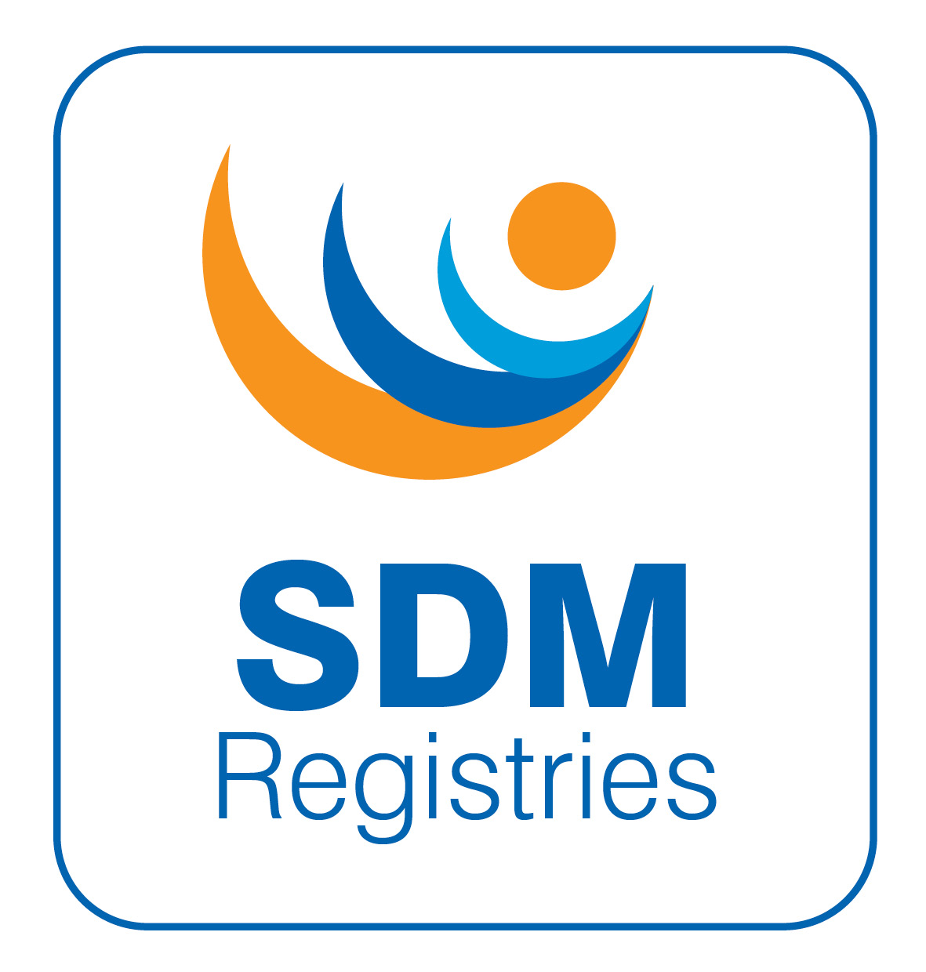

SDMregistries Clinical Study Protocol

 |  | Page
1 | Administrative Information | 2
2 | Background and Rationale | 2
3 | Study Objectives | 2
4 | Study Design | 2
5 | Study Population | 2
6 | Data Collection and Study Procedures | 2
7 | Outcome Measures | 3
8 | Data Management and Quality Assurance | 3
9 | Ethical Considerations | 3
10 | Project Management and Governance | 3
11 | Stakeholder Engagement | 3
12 | Data Ownership | 4
13 | Access Procedures | 4
14 | Timeline and Milestones | 4
15 | Risk Management | 4
16 | References | 4
Appendix 1 | Ethical Approvals
Appendix 2 | Conditions of Ethical Approval
Appendix 3 | UK NHS IRB/Ethics application and Project Description
Appendix 4 | Data Access Policy
Appendix 5 | Data Protection Approval Letter
Appendix 6 | Data Dictionary
Appendix 7 | Data Flow in the Registry
Appendix 8 | Data Sharing Agreement – Data Disclosers (for centres adding data into the registry)
Appendix 9 | Participant Information Sheets (English) – Adult, Parent, Child 8-12y, Child 13-15y
Appendix 10 | Informed Consent Form
Appendix 11 | Privacy Notice

Created Date: 010326
Review Date: 010327

- Administrative Information
Full Title: International Registries For Rare Conditions Affecting Sex Development & Maturation
Short Title: SDMregistries
Version Date: March 2026
Principal Investigator: Professor S. Faisal Ahmed
Lead Institution: Office for Rare Conditions (ORC) Registries, University of Glasgow
Collaborating Institutions: Expert Centres (list available from ORC Registries)
Study Type: Non-interventional, retrospective and prospective, multinational registry study
- Background and Rationale
Patient registries collect uniform data to identify outcomes for populations with specific conditions or therapies. The I-DSD Registry was conceived following the Chicago Consensus meeting in 2005 (1) and the prototype ESPE DSD Register became the EuroDSD Registry in 2008 (2) and the International DSD (I-DSD) Registry in 2011 (3). The original platform subsequently developed dedicated modules for CAH (I-CAH, 2014) (4), TS (I-TS, 2022) and HH (I-HH, 2025) (5) and this common platform was renamed the SDMregistries platform.

- Study Objectives
Primary Objective
To establish and maintain a global registry capable of supporting natural history studies for rare conditions affecting sex development & maturation
Secondary Objectives
• To develop a sustainable and quality-assured registry infrastructure.
• To establish a multi-stakeholder governance and data-sharing framework.
• To facilitate high-quality scientific outputs and data utilisation across partners.
- Study Design
This is a non-interventional, mixed retrospective and prospective, multinational registry study designed to collect and monitor data on patients who are eligible to be included on the SDMregistries platform. The registry will include a centralised electronic data capture system with a core dataset and diagnosis specific modules. The platform will enable the collection of clinician- and patient-reported outcomes and adverse events, with some translation and localisation features to ensure global accessibility.

- Study Population
Inclusion Criteria:
- Patients who are affected by a condition affecting sex development or maturation that is included on SDMregistries platform
- Consent provided by patients or guardians, as appropriate.

Exclusion Criteria:
• Patients with a clinical condition that is not included on SDMregistries platform
• Inability or unwillingness to provide informed consent.
- Data Collection and Study Procedures
The SDMregistries platform will collect data through structured condition-specific sections including core data, diagnosis, therapy, adverse events, clinician-reported outcomes, and patient/parent-reported outcomes. Data quality will be ensured through minimization of datasets, minimal use of free text, standardization of responses, automated validation, internal logic checks and external data verification and education and training of reporters. Data access will be governed by the Data Access Committee (DAC) following established procedures that have been established in other successful registry initiatives launched by the lead institution. The DAC ensures ethical and transparent data sharing practices. Its remit includes reviewing applications for data access, ensuring compliance with ethics approvals, and maintaining data custodianship standards. The DAC provides independent scientific advice, evaluates project overlap, and guides on dissemination and publication practices. The DAC reports to the Steering Committee through its Chair.

- Outcome Measures
Primary Outcome:
• Establishment and operation of a functional registry platform for conditions affecting sex development and maturation
Secondary Outcomes:
• Development and validation of the condition-specific modules
• Data completeness and accuracy metrics
• Scientific publications and dissemination outputs
- Data Management and Quality Assurance
Data will be managed centrally by the Office for Rare Conditions Registries at the University of Glasgow. The project operates under a comprehensive Data Access Policy (DAP) that governs all aspects of data handling, use, and protection. Data quality will be checked by several methods and quality assurance will be conducted using remote review meetings. Data security will comply with GDPR and institutional policies. When required, complex analyses will be performed internally or under the supervision of external investigators. Depending on the requirements of the investigators, raw data will also be shared with investigators but in this case all identifiable data shall be removed. All data sharing and scientific analysis will be regulated through formal Data Sharing Agreements that will adhere to the purpose of data sharing and as described in the data access request that was approved by the DAC. Annual analyses will also be performed by the PMG to evaluate data accrual, quality, and content, generating progress reports for the Steering Committee. All results will be disseminated transparently, with due acknowledgment of the SDMregistries contributors and infrastructure.

- Ethical Considerations
Ethical approval has been obtained through the University of Glasgow Research Ethics Committee and partner institutions will be expected to obtain their local centre approvals before starting to enter patient data. Opt-in or opt-out consent will be obtained prior to inclusion. The registry will adhere to the principles of confidentiality, transparency, and patient engagement. Patient representatives will be active members of the Scientific Study Group and governance committees.

- Project Management and Governance
The SDMregistries Project Management Group (PMG) will coordinate daily operations and report to the Steering Committee. The Data Access Committee (DAC) will evaluate data requests for these studies and monitor the progress of the studies. Representation in the PMG and DAC will include academic, clinical, patient and industry stakeholders. All activities of the project are also reviewed by the University of Glasgow’s Data Protection Team and the Legal and Contracts team. This multi-tiered governance framework ensures that all registry activities adhere to ethical, legal, and scientific standards.

- Stakeholder Engagement
Stakeholders include patients, clinicians, professional societies, and industry partners. Several patient organisations are involved in the project. Professional collaboration is established with several major endocrine societies including ASPAE, APPES, ANZSPED, ESPE, ESPU, PES, and Endo-ERN. The project engages with the public through its website and social media presence.

- Data Ownership
Data ownership is distributed across several stakeholders:
• Patients (and/or guardians) are the primary owners of their individual data, granting non-exclusive research licences to the University of Glasgow and authorised investigators through the consent process. They can request deletion of their own data.
• The University of Glasgow owns the database infrastructure.
• The reporter’s institution owns the aggregated clinical data for their patients and can request deletion and can also download all the data themselves.
- Once supplied to the investigator and processed, the data become research data, constituting the intellectual property of the investigator.
- The University of Glasgow, through the Office for Rare Conditions Registries, serves as the custodian of the data and is responsible for its security, ethical use, and long-term storage.

- Access Procedures
Access to registry data follows a formal process:
1. Investigators submit a Data Request Form and a Data Sharing Agreement to the PMG.
2. The PMG reviews submissions for completeness and forwards them to the DAC.
3. The DAC reviews the scientific and ethical integrity of each request and provides feedback using the DAC Feedback Form.
4. Approved requests are listed on the SDMregistries website, with annual reports and lay summaries of all ongoing analyses.
5. Where overlap exists between proposed and ongoing projects, applicants are encouraged to collaborate with each other to avoid duplication.

- Risk Management
- Identified risks include delays in reaching data field consensus, excessive dataset size, and technical implementation challenges. These are mitigated through regular meetings, iterative feedback, and coordinated project management.
- Technical and ethical risks are considered low due to the consortium’s prior experience with similar registry systems.

- References
- Hughes IA, Houk C, Ahmed SF, Lee PA; LWPES Consensus Group; ESPE Consensus Group. Consensus statement on management of intersex disorders. Arch Dis Child. 2006;91:554-63.
- Ahmed SF, Rodie M, Jiang J, Sinnott RO. The European disorder of sex development registry: a virtual research environment. Sex Dev. 2010;4:192-8.
- Lucas-Herald AK, Ali SR, McMillan C, Rodie ME, McMillan M, Bryce J, Ahmed SF. I-DSD: The First 10 Years. Horm Res Paediatr. 2023;96:238-246.
- Tseretopoulou X, Bryce J, Chen M, McMillan M, Lucas-Herald AK, Ali SR, Ahmed SF. The I-CAH Registry: A platform for international collaboration for improving knowledge and clinical care in congenital adrenal hyperplasia. Clin Endocrinol (Oxf). 2024;101:397-404.
- Rhys-Evans S, d'Aniello F, Alexander EC, Dinah IF, Heger S, Nordenstrom A, Rohayem J, Howard SR. Gonadotropin Therapy for Mini-Puberty Induction in Male Infants With Hypogonadotropic Hypogonadism. J Clin Endocrinol Metab. 2025;110:e921-e931.

