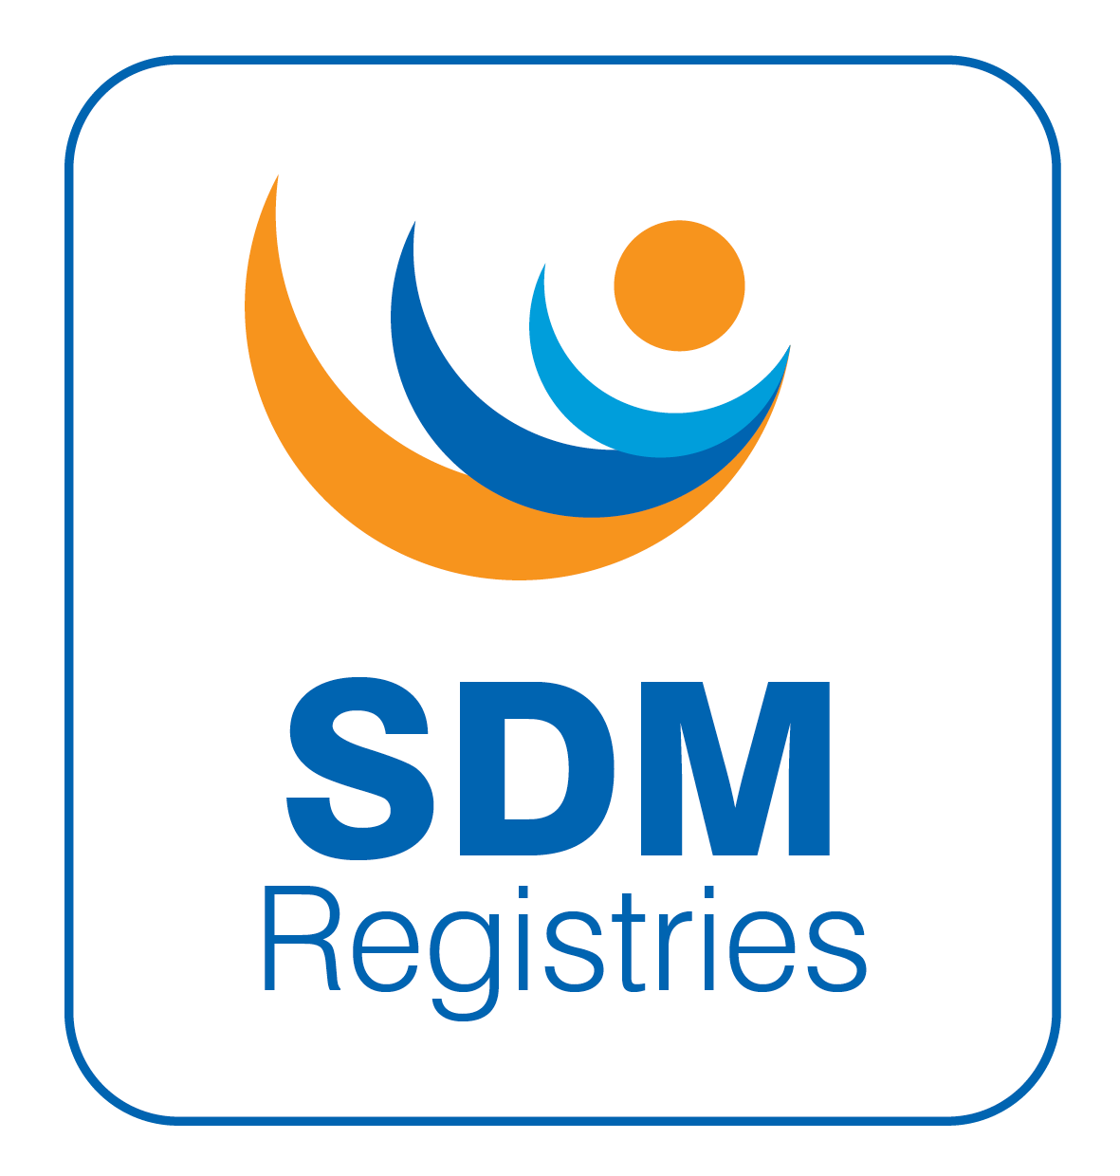
SDMregistries

Data Request Form
1 Mandatory questions are marked with a star (*)

Read the document C onditions of approval of the SDMregistries

Read the P rocedure for obtaining data from the Registry for research

Read the D ata Access Policy

Read the P ublication Plan

Consulted the D ata Dictionary to identify variables required

Consulted the list of A ctive and Completed studies

Read the P rocess for using & reusing data from the registry Read the P rivacy Notices
- Please confirm that you have read all of the documents above before completing this form.*
- Yes
- No

Tips for completing this application form.
The form has Save and Continue later option. Please SAVE regularly if completing in one go.
It is recommended that you browse through the questions and prepare some sections of the application offline and then copy and paste into the web form.
An o ffline version of this form is available for preparing a draft of the application.

For help with this form please e-mail: info@sdmregistries.org
V9
Created: 01/01/22
Revised: 20/05/25
Review: 20/05/26

- The project must be discussed in detail with the P roject Management Groupat
least one month prior to the deadline. Please complete these mandatory questions to continue:
Discussed with (names of Project Management Team members) *
On (date(s) of discussion) *

- I confirm the project has been discussed in detail with the Project Management Group at least one month before the submission date. *
- Yes
- No

- Details of Principal Investigator ‡ *

Name
Email
Name and Address of Institution/Sponsor

- Details of Coinvestigator(s) ‡ *
Name, institution name & e-mail address

- Full Name of Project *

- Short Name of Project for Communication Purposes ‡ *

- This application has been discussed with all the coinvestigators *
Notification of approval of this application will be sent to all coinvestigators

 Yes No

- This application is: *

 a new application
 a revision of a previously submitted application  an extension to a previously approved project

- Details of previous application/study (NA for a new application)
Study ID or Date of submission to DAC, Short title & PI

- What are the main reasons for requesting data access from SDMregistries? *

To only assist with designing a new project without any patient level data To perform a survey of participating centres
To obtain deidentified patient data from the registry to perform a study Any other project

- Background and rationale for support required (max 500 words) *

- What is the primary hypothesis of the project? *

- State the inclusion criteria of the cases that will be recruited *

- State the exclusion criteria of the cases that will be recruited *

- Do the investigators intend to collect any data or biomaterial that are not collected as part of routine clinical practice? *
If intending to exchange materials (bio samples), there may be a need for a separate centre-to-centre transfer agreements.
 Yes No

- Do the investigators have ethics/IRB approval for collecting this additional data or biomaterial? *
 Yes No

- Please provide details of ethics/IRB body and date and duration of approval *

- Is there a plan to apply for ethics/IRB approval? *

 Yes (Specify)
No

- Please explain whether you have protected time or local resources for performing the research that will be required once the data are supplied to you. *
(e.g. to clean the data and analyse the data, follow-up on queries, liaise with the Project Management Group and writing outputs)

- How will this project improve the health of the people with the condition that is being studied? *

- Have you received data from the SDMregistries previously? *

 Yes No

- Were there any peer-reviewed publications from the project(s)? *

 Yes No

- Please provide list of peer-reviewed publications from each project *

- Date of last report *
dd.mm.yyyy

- Please add any additional/relevant information. The team may contact you for further clarification.

- Form completed by: *

Name and e-mail of person who completed the form

- Date of completion *
dd.mm.yyyy

Items marked with the symbol ‡ will be shared with the Registry users who are invited to participate in the study. Items marked with an asterisk * are mandatory

