I-DSD Training Workshop – Stockholm 2024
Date & Time: Wednesday 26th June 2024, 08:45am-12.30pm
Location: Sune Bergström Aula, Karolinska University Hospital
Target Audience: New investigators interested in DSD
Aim of Workshop: Interactive small group sessions that are aimed at improving clinical and research skills.

Programme

Participants will move around the 3 out of 4 workstations in small groups and will have the chance to provide feedback during the debriefing session at the end.

8:45-9:00 Reception – Allocation into groups.
9:00-9:15 Welcome and introduction to the workshop - Faisal Ahmed
9:15-10:00 1st Session (Group Rooms by rotation)
10:00-10:45 2nd Session (Group Rooms by rotation)
10:45-11:00 Coffee
11:00-11:45 3rd Session (Group Rooms by rotation)
11:45-12:00 Debriefing/feedback
12:00-12:45 Lunch

Objectives of Workstations

Workstation 1: The I-DSD/I-CAH/I-TS registries (SDMregistries)
Room: J3.13 Marc Bygdeman (36 pax)

Facilitator: Dr Malika Alimussina, Glasgow UK

- I-DSD/I-CAH/I-TS registries activities
- Interactive hands on work with the I-DSD/ I-CAH/I-TS registries

Participants will have the opportunity to work online during the workshop to navigate the Registry. The research potential of the Registry will be highlighted with an overview of past and present activities.. If you have a Wi-Fi enabled laptop, please bring it
Temporary Username: jillian.bryce+IDSDTW@gmail.com
Temporary password: IDSDworkshop1!

Workstation 2: DSD Diagnostics
Room: J3.03 Bengt Robertson (20 pax)

Facilitator: Dr Sabine Hannema, Amsterdam, Netherlands

Participants will be able to exchange ideas about the diagnostic approach to DSD in this case-based workshop. Advantages and pitfalls of different diagnostic tests will be discussed.
Workstation 3: Communication with patients and parents
Room: J3:14 Kerstin Hagendeldt (44 pax)

Facilitator: Dr Anna Strandqvist, Stockholm, Sweden

Participants will discuss their experiences of what works well, and does not work, when discussing DSD with parents of recently diagnosed children. Cultural differences will be considered. Particular topics of discussion will include: illness uncertainty and stigma.
Workstation 4: Hormone replacement
Room: J3.01 Tore Curstedt (20 pax)

Facilitator: Prof Aneta Gawlik, Katowice, Poland

In this workshop we will discuss current approaches to pubertal induction and sex hormone replacement to sustain puberty. Participants will have opportunity to exchange their experience on various hormone replacement protocols and used, also off-label, preparations.

Sune Bergström Aula floorplan for Training Workshop
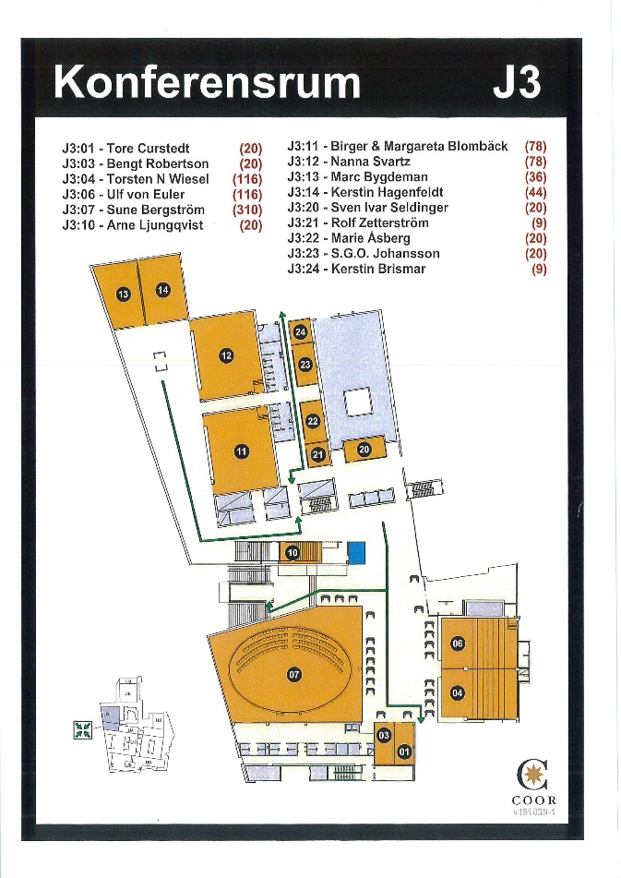
J3:07 Sune Bergström (310 people)
J3:14 Kerstin Hagenfeldt (44 people)
J3:13 Marc Bygdeman (36 people)
J3:03 Bengt Robertson (20 people)
J3:01 Tore Curstedt (20 people)

